**Fixes for Cloudera Manager Hanging Issue**

Daya Rudhramoorthi

Adjunct Faculty

Northeastern University

We have noticed that in some instances, after installing and starting Cloudera QuickStart in Hyper-V, VMWare or Oracle VirtualBox, upon clicking Cloudera Manager in Mozilla Firefox browser, was taking very long time (at times more than 1 hour or so) to connect and display login/password screen.

Below are the two fixes that seems to be working fine. Feel free to update this document, if additional details are found regarding this issue.

**Note – Below detail is to fix hanging problem in Cloudera. This needs to be performed only once.**

**I found 2 different solutions and documented both of them here. Try Fix 1 first, wait for 10/15 mins, start Cloudera Manager. If it is still hanging, try Fix 2.**

**Fix - 1**

1. Close your Mozilla Firefox (using the x below on the right top below cloudera)

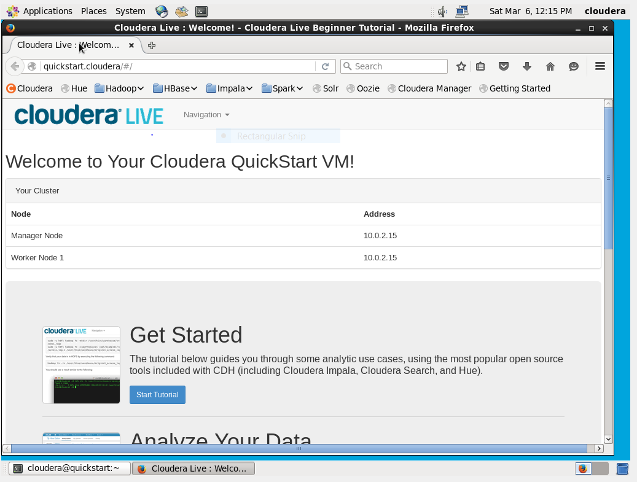

1. Click “Launch Cloudera Express” Icon in the Cloudera desktop

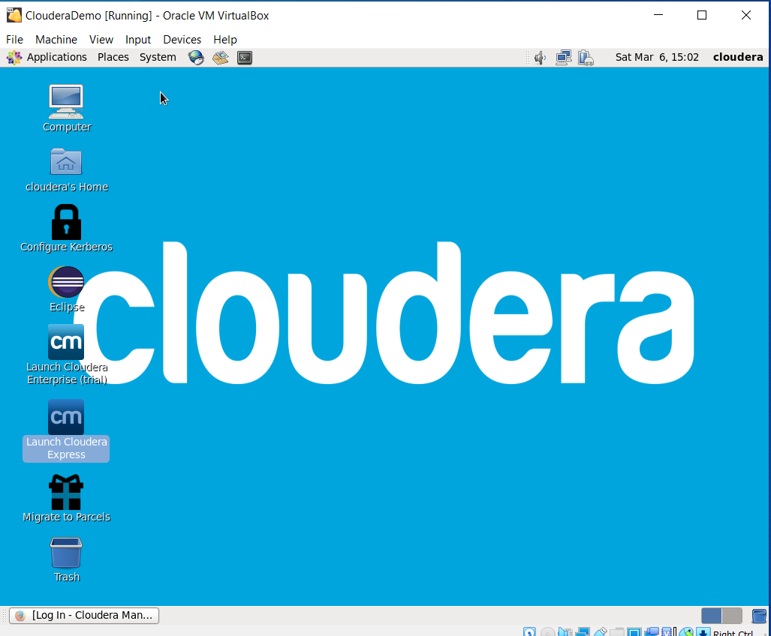

1. Right Click and select properties

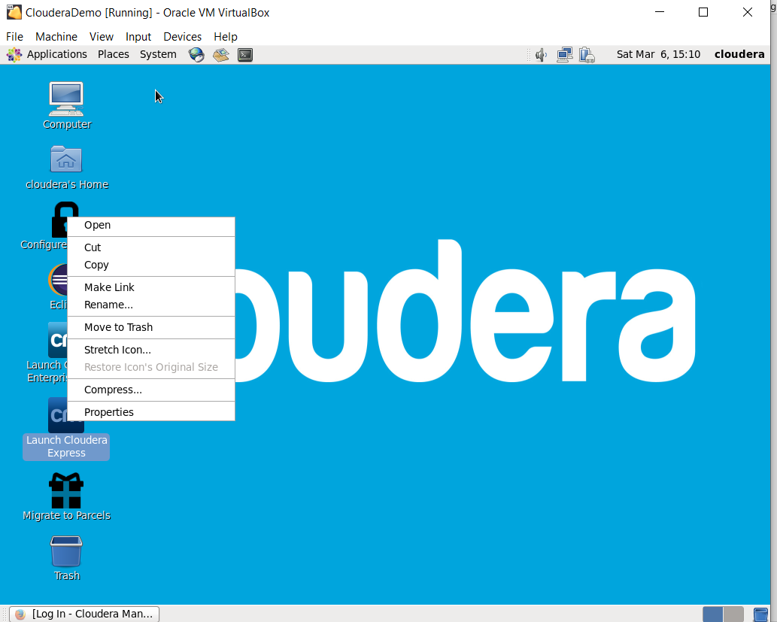

1. In the properties pop-up, go to “Command line” and you will see default value as --pause

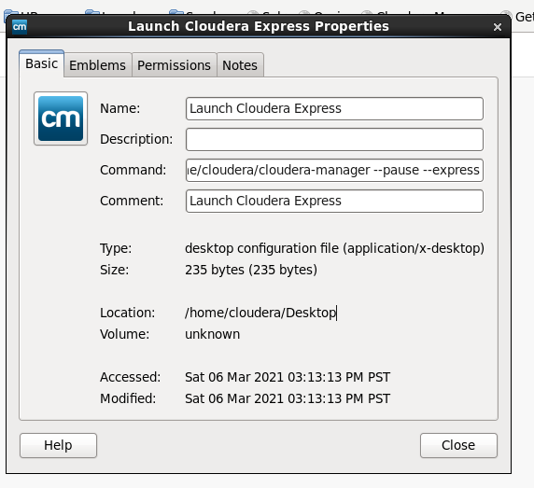

1. Replace –pause with –force

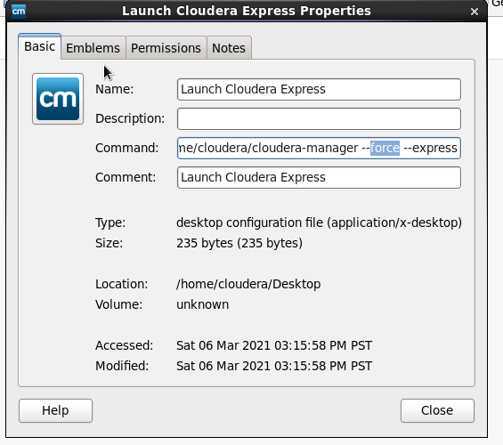

1. Click Close and this will take back to Cloudera desktop again.
2. “Launch Cloudera Express” Icon and this will restart all services.

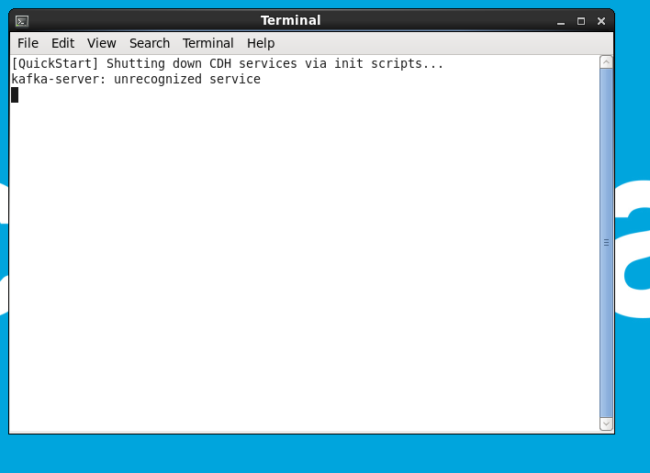

1. Wait for few mins and you can see messages for all the services restarting. This pop-will close automatically, once all the services are restarted.

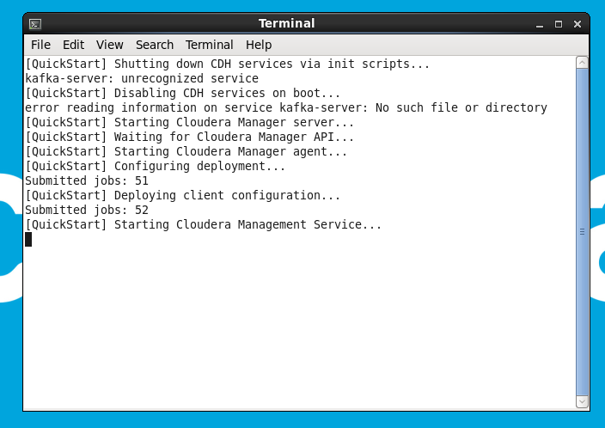

1. Click earth/mouse icon to start Firefox browser.

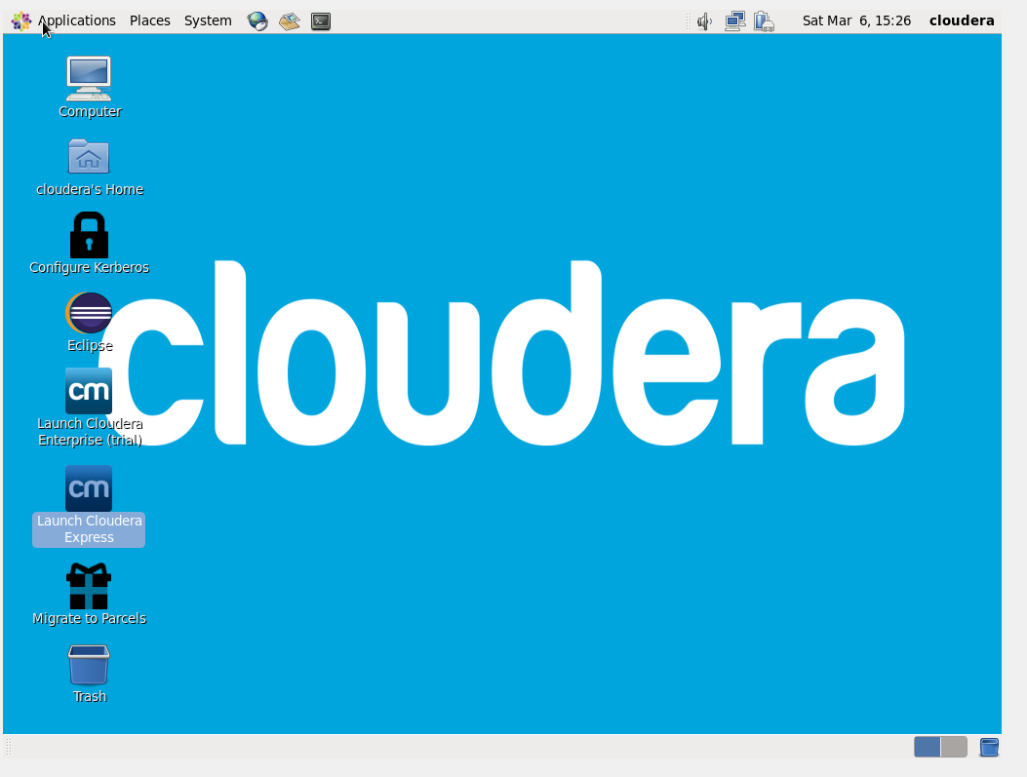

1. After opening Firefox browser, click Cloudera Manager and it should move forward and ask for confirmation as below.

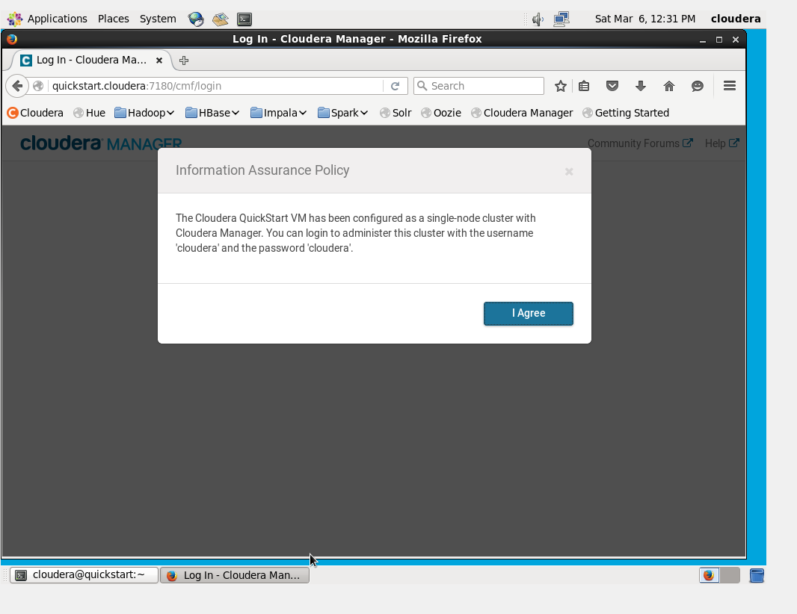

**Fix - 2**

1. Close your Mozilla Firefox (using the x below on the right top below cloudera)



1. Click to Terminal to run command line. This is small monitor on the top menu’s right side icon

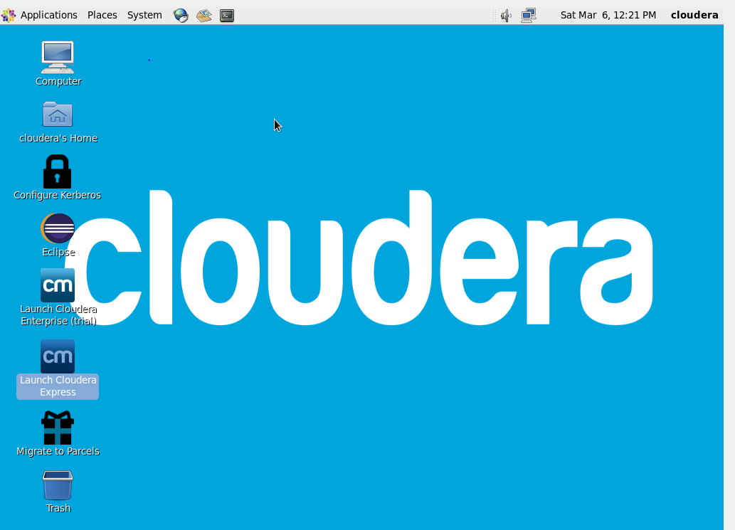

1. This should open a terminal to type commands.

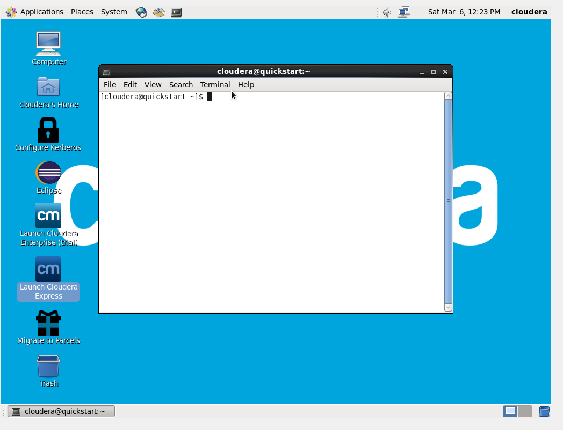

1. Type below command and press enter (copy/paste may not work, so you need to actually type it)

 mysql -uroot -pcloudera

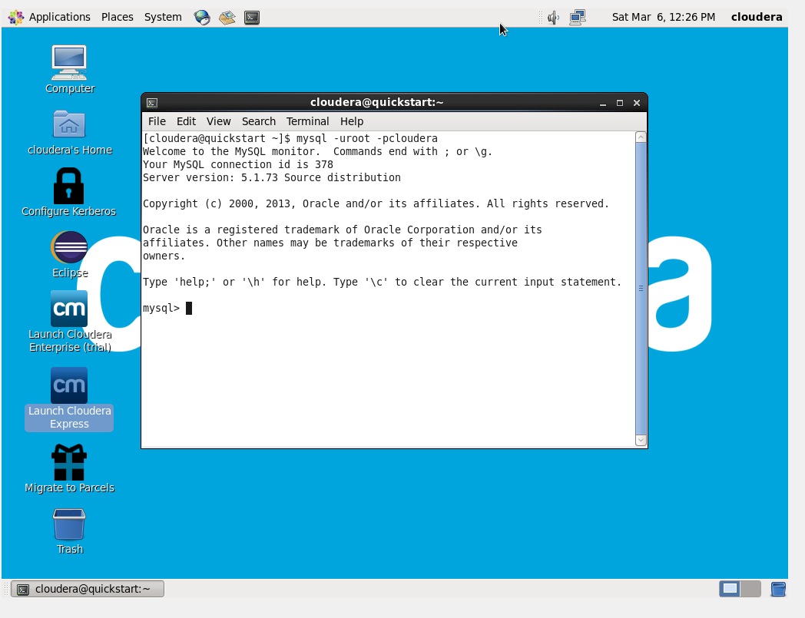

1. Then open Firefox Browser, by cling that earth/mouse icon



1. After opening Firefox browser, click Cloudera Manager and it should move forward and ask for confirmation as below.

